

Hours:

Mon 4-8 pm

Tues 9-11, 12-4pm

Wed 9-11, 12-8pm

Thurs 9-11, 12-8pm

Fri 9-11, 12-4pm

Sat 9-1pm

**October 2022**

**Celebrating 130 Years in 2023**

**130 Decorated Pumpkins CHALLENGE**

130 decorated pumpkins at the library?? We think we can do it, with YOUR HELP.

**WE HAVE THE PUMPKINS.**

Pick your favorite to carve or decorate in any way you like. Some are orange. Many are white.

One green one could be Frankenstein.

**PREFER TO USE YOUR OWN?**

If your carving or decorating vision requires something other than what we have, go for it.

**NO CRAFT SUPPLIES? NO PROBLEM!**

The library will be set up THREE DIFFERENT TIMES for you to use OUR CRAFT SUPPLIES to make your masterpiece. Paint. Hot glue. Glitter. Ribbon. Pom poms. The list goes on. Have items you’d like to add?

Bring ‘em. Need to work in stages? Fine. Leave your pumpkin or bring it back to work some more.

**NOTE: We have safety scissors, but if you require a carving knife, awl, or adult scissors, please brings those with you.**

**IS IT ONE PER FAMILY? NO.**

You may work on one as a family, or use little ones for little hands to make all on their very own.

**Questions? Contact us! Here’s the schedule.**

Monday, Oct. 10 and following – pumpkins available for pick-up, **first come, first served**

Saturday, Oct. 15, **10am – 12pm** – craft supplies available

Wednesday, Oct. 19 & 20, **5pm – 7pm** – craft supplies available

Monday, Oct. 24 – deadline to return (If it’s later we’ll still take it.)

**We hope you’ll join in the fun!**

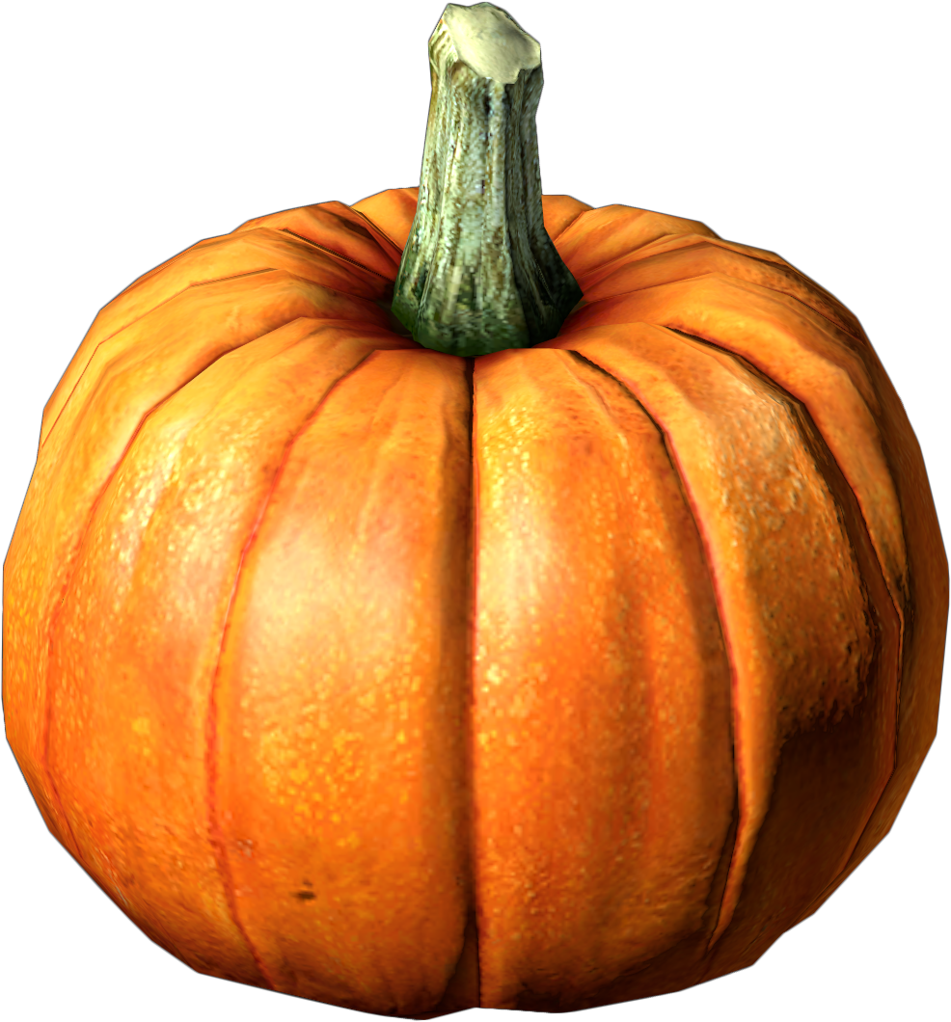



**Toddler**

**Story Hour**

**Tuesday, Oct. 18**

**10 – 11am**

Join us for a themed story time complete with sensory stations and snack.

Registration is not required but **IS** helpful!

**Call or email us at: elkhartlibrary@mchsi.com**

**Flu Shot Clinic**

**Thursday Oct. 27**

**4 - 5:30pm**

Bring your insurance card!

Blank vaccination forms available in advance at the library and on our website.

**elkhartlibrary.lib.il.us**





**Medicare Education**

**Monday, Oct. 17, 5:30pm**  **Saturday, Oct. 22, 10:30am**

Find Medicare confusing? Wish you knew more?

Wonder if you’ve missed something?

Mitchell Hudson will be here to educate and

answer questions, so we hope you’ll join us.

*There is no cost or obligation*, and registration is not required. If you do plan to attend, we’d

love to know in advance so we can prepare for you.

**Stop by the library or call us at 217-947-2313**